AS Psychology


Unit 541: Psychological Investigations

Introduction & Methods Overview

Name: ……………………………………………………………………………………………………………….………

Learning Objectives

You should be able to:
1. Write the aim for a piece of research.
2. Recall that there are three types of hypothesis: research, alternative and null.
3. Recall that alternative hypotheses can be directional or non-directional.
4. Write null and alternative (both directional and non-directional) hypotheses.
5. Recall three different methods of selecting a sample: opportunity, random and self selecting.
6. Describe the strengths and weaknesses of the different methods of selecting a sample.
7. Describe the difference between quantitative and qualitative data.
8. Describe the strengths and weaknesses of both quantitative and qualitative data.
9. Outline what is meant by reliability and identify different types.
10. Outline what is meant by validity and identify different types.
11. Recall and describe the ethical principles that govern psychological research.
12. Recall the purpose of a Brief, set of Standardised Instructions and a Debrief.
13. Identify where ethical principles have been covered in a Brief, set of Standardised Instructions and a Debrief.
14. Describe the three levels of measurement of data: nominal, ordinal and interval and be identify these levels of data.
15. Define the term measure of central tendency and define the three: mean, median and mode.
16. Calculate the mean, median and mode.
17. Outline the strengths and weaknesses of the mean, median and mode.
18. Define the term measure of dispersion and define the two: range and standard deviation.
19. Calculate the range.
20. Interpret standard deviation scores.
21. Outline the strengths and weaknesses of the range and standard deviation.
22. Draw a table and label it.
23. Identify the different types of graph and be able to draw them.
Introduction

In everyday life we all speculate about the behaviour of others: What is she wearing that? What does he see in her? We also want to understand our own behaviour: Why couldn’t I remember that in the exam? What did that dream about unicorns mean? The difference between this everyday speculation and psychology is that psychology tries to find answers by conducting systematic research in order to find the answers to these kind of questions.

An easy way to find out information is to look at what is happening around you and record it. This is the process of observation. The main topic of psychological research is the behaviour and experiences of people, if you want to know what someone thinks, feels or does, the obvious thing to do is to ask them. This gives us first-hand accounts called self-reports. As evidence builds up psychologists start to develop theories which they then test to see if they are right or not, they do this by conducting experiments. Other issues are best explored by looking for associations between them, psychologists then use correlation. So there are several methods employed by psychologists when carrying out research.

We will be looking at all these in more detail later in the course. However, whatever the method used, the events followed when conducting a piece of research would be:

- Formulating aims and hypotheses
- Designing the study
- Analysing the results

Formulating aims

A piece of research begins with an idea that you wish to investigate. Having chosen a topic area the aim of the research must be determined. The aim gives us an idea about what the researcher hopes to achieve. So an aim that states ‘The aim of this project is to look at gender differences’ is far too vague.

The aim is easy to write if you begin with:
‘To investigate ……’
For example: ‘To investigate the effect of alcohol on a person’s ability to drive.’


To do:
Write aims for the following studies:

- A psychologist looked at how many hours studying students did in a week and then compared this to their final AS-grade.

- A researcher wanted to see if blondes have more fun.

- A scientist wanted to find out if boys are more mathematically able than girls.

Formulating hypotheses

When completing GCSE science coursework you probably had to write a prediction. A hypothesis is a bit like a prediction, except that it is not worded the same. A prediction can involve a lengthy paragraph and will include an explanation as to why you think that will happen. A hypothesis, however, is a single statement saying what will happen.

A hypothesis can be defined as:
‘A testable statement made at the beginning of an investigation which the researcher aims to support or refute.’

They are written in present tense and have the word significant in them, i.e. ‘There is a significant difference ……..’

There are three types of hypothesis:
- Research
- Alternative
- Null

The research hypothesis
This is a general prediction made at the beginning of a study as to what you expect will happen.
For example: ‘Short term memory declines with age.’

The alternative hypothesis
This is the research hypothesis stated very precisely and is referred to as the H₁. It is called experimental when an experiment is being carried out.

If the alternative hypothesis predicts the direction of the results then it is called a directional hypothesis or a one-tailed hypothesis.

For example: ‘The number of words remembered from a list of 25 by 70-year-olds is less than the number remembered by 20-year-olds.’

If the alternative hypothesis does not predict the direction of the results and just says that there will be a difference then it is a non-directional or a two-tailed hypothesis.
For example: ‘The number of words remembered from a list of 25 by 70-year-olds is different to the number remembered by 20-year-olds.’.’

Notice that the alternative hypothesis gives us information about what is being compared. (In this case …………………………. and ………………………….)
It also tells us how what is being investigated is being measured. (In this case …………………………………………………………………………………………………………………………………………………………..)
As a result the hypothesis is said to be operational.

The null hypothesis
This is hypothesis of no difference. It always starts ‘There is no difference ……….’ or ‘There is no relationship ……….’ The null hypothesis is referred to as the H₀.
For example: ‘There is no difference in the number of words remembered from a list of 25 by 70-year-olds and the number remembered by 20-year-olds.’

To do:
Identify whether these hypotheses are research, null or alternative hypotheses:

- There is no difference in the number of units of alcohol drunk in a week by women and men.

- People who drink five mugs of coffee a day complete a crossword faster than those who drink five mugs of tea.


- There is a relationship between the number of car crashes a person has an the length of time they have had their driving licence.

To do:
For each of the following hypotheses identify if it is directional or non-directional:

- 5-year-old children choose to eat chocolate more times than crisps than 10-year-old children when given a choice between the two.

- Girls spend a different amount of time talking in a one-hour lesson to boys.


- There is a relationship between points score at GCSE and the salary a person receives.

- People who have slept for six hours or less the previous night are more irritable than people who have slept for more than six hours.

To do:
Write a hypothesis for each of the studies below, its up to you what kind you write but you must write at least one of each type. For each one you must identify:

- whether the hypothesis will be looking for a difference or relationship
- what is being compared
- how to measure what is being investigated

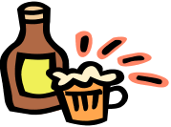
- A psychologist conducts a study on students to see if the number of units of alcohol drunk in a week is linked to IQ.

- A study investigates the length of time babies spend looking at simple shapes and human faces.

- A gardener compares the number of tomatoes produced by plants grown in ‘grow bags’ and in the ground.


- A psychologist investigates the score in a French grammar test in teenage girls and boys.


Sampling methods

Once you have decided on your aim and hypotheses you will need to decide who you are going to study. First decide which group (or target population) you are interested in, this will depend on your research, so if you were comparing the height of 6-year-old boys and 6-year-old girls your target population would be all 6-year-olds. It would be impossible to measure the height of all 6-year-olds hence you must take a sample. There are several methods for selecting a sample from your target population.

To do:
Write a definition of the sampling methods given below and then describe how you would obtain a sample using each method:

- Random

- Opportunity

- Self-selecting (often called volunteer)
To do:

- Complete the table below with the heights of all the students in your class:

Student | Height (cm) | Student | Height (cm)
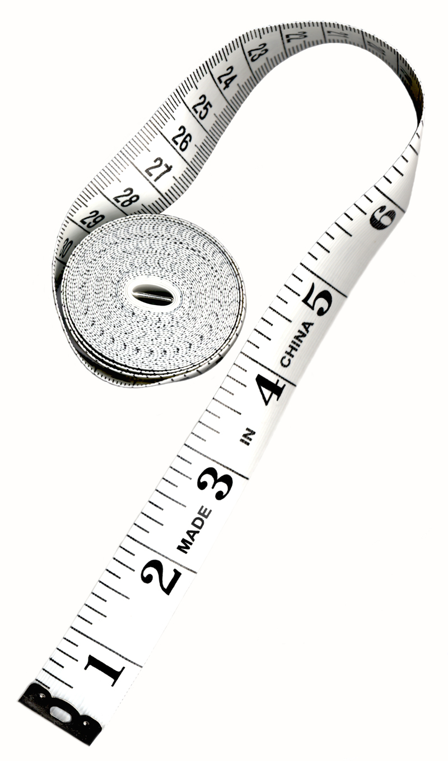

- Calculate the mean height by adding up all the heights and dividing by the total number of students in your class, record it below:

- Put all the names of the students in your class in a hat; pick eight of the names out. Work out the mean of this sample, record it below:

Which sampling method have you used here?

- Work out the mean height for the first eight students to record their height, record it below:

Which sampling method have you used here?

- Work out the mean height for the eight students sat nearest to you, record it below:

Which sampling method have you used here?
Strengths and weaknesses of the different sampling methods
To do:
Cut out the boxes of strengths and weaknesses on the next page. For each, decide whether it is a strength or a weakness and which sampling method it applies to. Stick the boxes in an appropriate order below:

Expensive. | Inexpensive. | Quick.
Biased sample as it’s easy to approach potential participants of same social/cultural group and maybe not all the target population is available to select from. | Will give access to a wide variety of participants. | Biased sample as participants are likely to be highly motivated and/or have extra time on their hands.
 | Time consuming.
 | Unbiased sample.
May end up with a biased sample as not all participants identified will participate. | Only possible when the target population is small. | Easy to do as you just use the first participants you can find that fit the target population.

Quantitative and Qualitative data

Quantitative data is data that is in numerical form.
For example: I drank six cups of tea yesterday.

To do:
Think of three more examples:

Qualitative data is data that is in descriptive in form.
For example: I enjoyed going to see the new Indy film.

To do:
Think of three more examples:
Both types of data have their strengths and weaknesses.

To do:
Complete the spider diagrams below, using one colour for strengths and one for weaknesses:

Quantitative data
Qualitative data
Reliability and Validity

All psychological research has to be designed. A key question for psychologists when designing this research is - how do I test the quality of my study? The concepts of reliability and validity are central to this question.

Reliability
Another word for reliability is consistency; if something can be repeated it is said to be reliable. There are two types of reliability:

Internal reliability  This refers to how consistently a method measures within itself. | External reliability  This refers to how consistently a method measures over time when repeated.

Can be assessed by the split-half method: correlating the results of half the items with the other half. | Can be assessed by the test-re-test method: correlating the results of the test on one occasion with another.

For example:
A ruler that measures the width of this page differently each time it is used lacks ___________ reliability.

A ruler which has different sized centimetres lacks ___________ reliability.

Validity
If the method used is measuring what it is supposed to, then it is said to be valid. There are several types of validity:

Face/content validity: involves examining the content of the method to see if it looks like it measures what it is supposed to measure.
Concurrent validity: involves comparing a new method with an already established method that measures the same variable, if the two agree then the method is valid.
Construct validity: refers to the extent to which a method measures a specific psychological trait.
Ecological validity: refers to whether the method measures behaviour that is representative of naturally occurring behaviour.

For example:
A memory test which asks participants to remember nonsense trigrams like HJK lacks ___________________ validity.

A memory test which asks participants about their favourite things lacks ___________________ and ___________________ validity.

A memory test which shows participants have much better memories than a well known and used memory test lacks ___________________ validity.

To do:
- Label the diagrams below to show whether they are reliable or unreliable and valid or invalid.

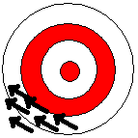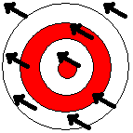

- The amazing new Psychomeasure! You can now easily measure your own intelligence, just wrap it around your round your forehead and read off the value.
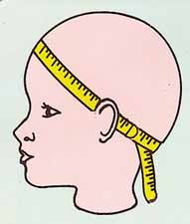

Is the Psychomeasure reliable? Why/why not?

Is the Psychomeasure valid? Why/why not?

How extravert are you?

Answer yes or no to the questions below:
1. Do you prefer to make instant decisions rather than reflecting for a while on what to do?
2. Would you prefer to take up a course in sketching rather than karate?
3. At parties do you prefer to listen to people rather than do the talking yourself?
4. Do you work best in a quiet atmosphere?
5. Have you got a wide circle of friends?
6. Have you ever done something stupid just for a dare?
7. Is it quite hard to get to know you?
8. Do you avoid spending too much time on your own?
9. Do you make new friends easily?
10. Are you the life and soul of the party?
11. Do you feel it is important to say what you think rather than keeping your opinions to yourself?
12. Do you prefer staying in rather than going out?
13. Do you ever dream of flying?
14. Do you prefer to work independently?
15. Are you too shy to tell people what you really think of them?
16. Do you discuss your decisions with other people?

Score 2 if you answered:
YES to Qs 1, 5, 6, 8, 9, 10, 11, 13 and 16.
NO to Qs 2, 3, 4, 7, 12, 14 and 15.

What it all means!
A score above 20 - Little Miss/Mr Extravert:
You are one outgoing cool cookie, living life to the full and having fun. You are full of energy and everyone loves being around you.

A score between 10 and 20 – Little Miss/Mr Balance:
You love people but you also don’t mind your own company. You love a bit of daring but you’re also happy with a good book!

A score below 10 – Little Miss/Mr Shy:
You’re an introvert, independent and cautious. Excitement is too much for you to cope with. Remember all work and no play makes for a dull dude!
To do:

Complete the questionnaire on the left and then complete the activities below:

- Comment on the face validity of the questionnaire.

- Assess the internal reliability of the questionnaire using the split-half method.

- Assess the external reliability of the questionnaire using the test-re-test method.

- Check the concurrent validity of the questionnaire by comparing the results with an existing test at: www.queendom.com

There is space on the next page for you to write.

Ethical issues

The British Psychological Society issues a code of ethics which provides guidelines for conducting research. You must understand ethical issues as well as be able top identify them in psychological research and implement them appropriately in your own investigations.

To do:
Briefly summarise the key ethical principles outlined by the BPS:



To do:
Look at the famous studies described below, identify which ethical principles each one violates and consider how, if at all, these could be overcome.

- Watson & Rayner (1920):
Little Albert was chosen, at the age of 9 months, by psychologist John Watson to participate in a study about learning. Albert was taken from an orphanage. In the first trial, Albert was presented with a white rat and allowed to play with it. The next time this happened, Watson and his colleagues produced a loud, frightening sound behind the child, by striking a steel bar with a hammer, whenever he touched the rat. Albert was frightened by the noise was made, but after several pairings of the rat with the sound, he began to show the fear response as soon as the rat appeared. The association of the white rat with the frightening sound perfectly demonstrated classical conditioning, however, that wasn’t all. Watson subsequently found Albert to be terrified of a non-white rabbit, a furry dog, a seal-skin coat and even the psychologist himself when wearing a Santa Claus mask with a white beard. Still evident seventeen days after the original conditioning, Albert’s fear had generalised to many different stimuli. Albert was taken away 31 days after the study began, and so was never desensitised to the objects that had terrified him.

- Milgram (1963):
Stanley Milgram made the headlines with his study into human obedience to authority. Taking place only months into the trials of WWII Nazi leaders, Milgram aimed to discover if those who committed the atrocities in concentration camps were truly evil people, or simply following orders from a higher figure. Participants were given the role of ‘teacher’, and told by the experimenter to administer electric shocks to the ‘learner’, a fellow participant in a separate room, if they answered questions incorrectly. The ‘learner’ was a confederate of the experimenter, and no actual shocks were given. With every wrong answer, participants were told to up the voltage of the shock administered, and as the volts increased, the ‘learner’ was heard to scream, cry and beg the ‘teacher’ to stop. Under the verbal prompting of the experimenter, 65% of participants continued to shock the ‘learner’, even after the screaming gave way to silence, until three shocks of 450 volts had been administered. Although no actual electric shocks occurred, participants were led to believe they had seriously harmed, or even killed, somebody. Milgram certainly proved his point that individuals are capable of evil acts when obeying authority.

- Zimbardo et al (1973):
The experiment was carried out by psychologist Philip Zimbardo and his colleagues, who constructed their mock prison in a basement in Stanford University. Twenty four normal, middle class, law-abiding men were randomly assigned roles as either inmates or guards in a ‘prison’. The ‘prisoners’ were dressed in ill-fitting smocks, known only by number and locked in cramped cells. The ‘guards’ were issued with wooden batons, military-style uniforms and mirrored sunglasses. So rapid was the dehumanisation of the prisoners and rise of brutality amongst the guards, that the two-week experiment was cut short after just six days, but not before even the scientists themselves had felt the lines between experiment and reality blur. The situation was soon virtually out of control. Prisoners experienced, and accepted even though they could have left the experiment at any point, increasingly sadistic treatment at the hands of the guards. This showed how easily good people can be manipulated by their environment to perpetrate or accept heinous acts.
A lot of the ethical principles are dealt with in the information you tell participants in their Brief, Standardised Instructions and Debrief.

To do:
Read the Brief, Standardised Instructions and Debrief below. Highlight each point where the researcher has covered an ethical principle and label it with the name of the principle.

Brief
"Hello my name is Fiona I was wondering if you could spare a few moments of your time to help me with some psychology research. The task is a very simple one; all I’d like you to do is try to remember a list of words. Are you happy to help me?"
(Participant replies)
If at this point the participant is not happy to help the following response applies:
"That is fine; thank you for your time."
If the participant is happy and wants to complete the task then the following response applies:
"If at any time you are unhappy and you do not want to carry on with the task, please tell me and you can go."

Standardised Instructions
Participant is shown to a nearby room.
“Are you still OK to help me?”
(Participant replies)
If at this point the participant is unhappy or does not want to carry on the following response applies:
"That is fine; thank you for your time anyway.”
If the participant is happy and wants to complete the task the following response applies:
"In front of you there is a word list, you have three minutes to try to remember as many words as possible. Do you understand what to do?”
(Participant replies)
“Thank you, your three minutes start now.”
(Participant tries to memorise the word list)
“Your three minutes is finished. I’d like you to turn the list over and write down as many words as you can remember.”
(Participant writes down words)
“That is the end of the task. Thank you very much for your help.”

Debrief
"Thank you for your help with my task. I have just asked you to remember a word list and recall it. Other psychologists have shown that we remember the words at the beginning and end of the list better than those in the middle. I am interested in whether this is true for both sexes, so I have asked equal number of male and female participants to complete the task you just have. I will now compare the results. The task you just finished was not a test and no one else will see your answers, I will not record your name. Are you still happy to have your answers included in my study? Today you have helped me a lot and I thank you again, goodbye.”

Descriptive Statistics

Descriptive statistics can be used to summarise and present the results of an investigation. A summary of the results is needed so that the reader can quickly see the overall pattern of the results and any differences that may be present.

There are three ways of displaying data, using:
- measures of central tendency
- measures of dispersion
- graphs

But before we look at these we need to look at levels of measurement of data.

Levels of measurement
This term refers to the way in which data is measured in psychology, the different levels simply extract different types of information. The main levels are shown below.

To do:
Briefly define each level and give an example:

Nominal

Ordinal

Interval

To do:
For each of the following decide which level of measurement is represented:

- A child’s age

- Anxiety rating on a scale of 1-10

- Time taken to complete a crossword puzzle

- Numbers of red and green cars caught speeding

- Number of letters that can be stored in STM

- Number of children who could complete a test and number who could not

- Attractiveness ratings given to David Hasselhof on a scale of 0-5

Measures of central tendency
These are methods of reducing the data set to a single number, which estimates the mid point of set of scores. There are three types:
- mode
- median
- mean

To do:
Summarise each measure of central tendency on the next page, using the PowerPoint.

For each you must include:
- a definition
- how to calculate it
- what level of data it is appropriate for
- at least one advantage and disadvantage of using it

Measures of Dispersion
These are methods of reducing the data set to a single number, which estimates the ‘spread-outness’ of set of scores. There are two types:
- range
- standard deviation

They are useful because sometimes when using measures of central tendency you could get two very different sets of values but with the same mean, median and modes which could be misleading. For example:

Data set 1 | Data set 2
58 | 27
59 | 36
60 | 60
60 | 60
61 | 84
62 | 93
The mean, mode and median is 60 for both!

To do:
Summarise each measure of dispersion on the next page, using the PowerPoint.

For each you must include:
- a definition
- how to calculate it
- what level of data it is appropriate for
- at least one advantage and disadvantage of using it
- how to interpret it

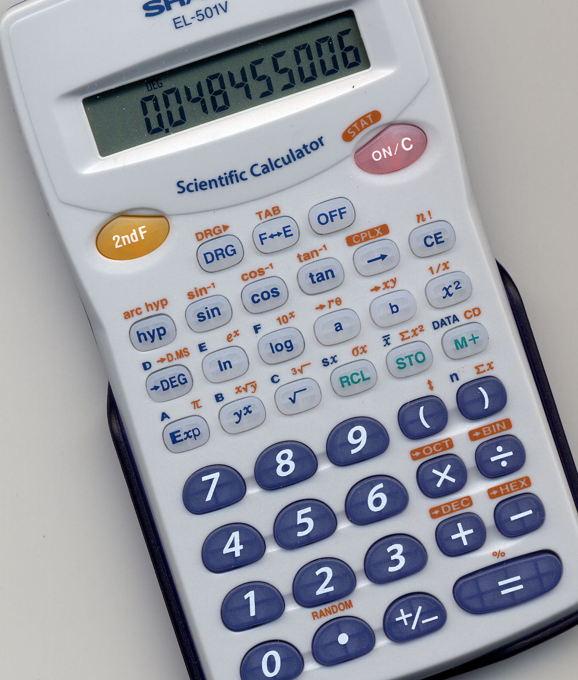

To do:
Have a go at calculating measures of central tendency and dispersion:

Q1
Calculate the mean, median, mode and range for the following sets of scores:

- 2, 3, 6, 9, 21, 5, 2, 13, 6, 15, 6

- 8, 7, 5, 4, 6, 4, 8, 7, 5, 7, 6

- 12, 10, 2, 9, 12, 7, 12, 3, 11, 9, 12, 8

Q2
Participant | Time to complete anagram (seconds)
1 | 15
2 | 16
3 | 14
4 | 12
5 | 17
6 | 16
7 | 14
8 | 16
9 | 15

- What measure of central tendency and dispersion should be calculated?

- Calculate them – show your working.

Q3
Participant | Rating given on a scale as to how good Gordon Brown is as Prime Minister (1 excellent → 5 poor)
1 | 3
2 | 3
3 | 5
4 | 4
5 | 1
6 | 2
7 | 5
8 | 3
9 | 2

- What measure of central tendency and dispersion should be calculated?

- Calculate them – show your working.

NB: You’ll never have to calculate standard deviation, just be able to interpret it.

Representing Data
Once the data for a study have been collected, decisions have to be made about how the data will be represented or displayed visually.

There are several ways:
- tables
- graphs

Tables
All tables must be fully labelled with a clear title and column headings.

Condition | Mean number of words recalled from a list of 20 | Range number of words recalled from a list of 20 | Standard deviation number of words recalled from a list of 20
Organised word list | 14 | 6 | 1
Unorganised word list | 9 | 6 | 3

To do:
Complete the following tasks:

- Write a suitable title for the table of data above.

- Draw and label a table for the data below:
A psychologist studied five pairs of twins, for each pair he tested their IQ. The first pair had an IQ of 42 and 45, the second pair of 57 and 61, the third pair of 50 and 55, the fourth pair of 18 and 14 and the fifth pair of 25 and 20.

Graphs
There are a variety of different types of graph, some common ones we will come across are:

Line Graphs
A line graph is often used to show the relationship between the IV (x-axis) and DV (y-axis). For a line graph to be appropriate the measurement along the x-axis must be continuous not categorical.
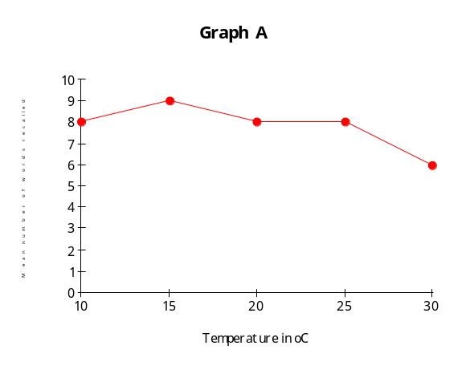
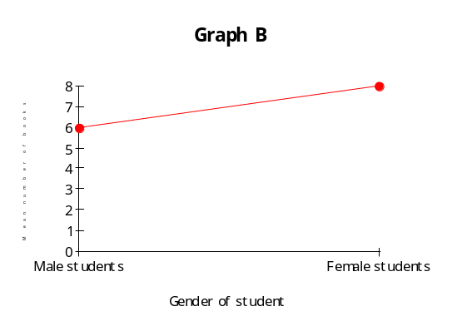

Use Graph A: How many words on average are remembered in rooms of 22^{O}C?

Use Graph B: Who borrows on average 7 books a year?

Therefore, which graph, A or B, is appropriate?

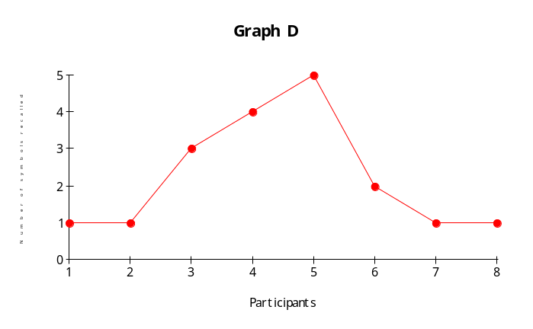Another common error is to draw a graph with participants along the x-axis:
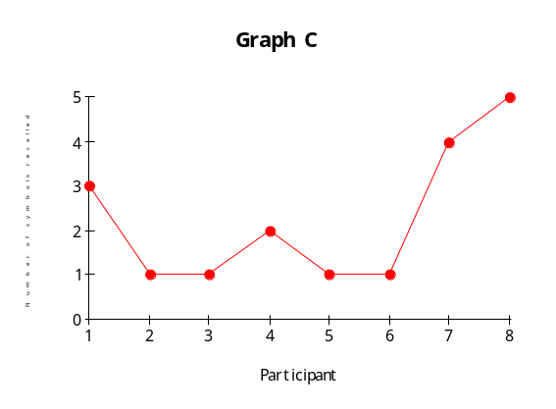

Look carefully at graphs C and D, what is the problem with this kind of graph?

Bar Charts
A bar chart displays the frequencies (y-axis) of categorical variables (x-axis).

Histograms
A histogram is a bit like a bar chart, except that it displays frequencies (y-axis) of continuous variables (x-axis). The variable is divided into intervals that are all the same numerical size.
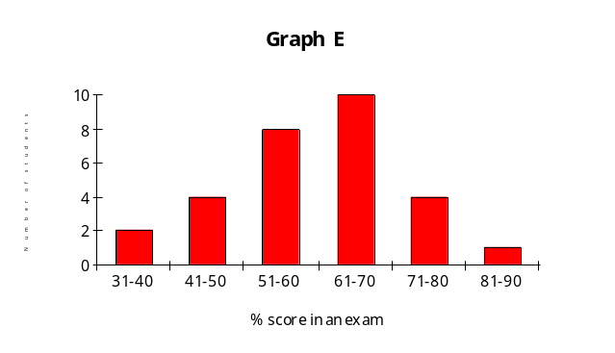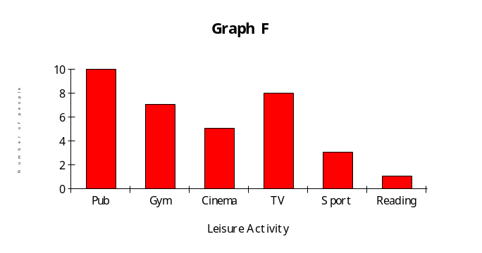

Graph E is a

Graph F is a

Scattergrams
This is a graphical display of paired data; the y-axis displays the scale for one of the paired values, the x-axis the scale for the other. They are used to display relationships in correlations.
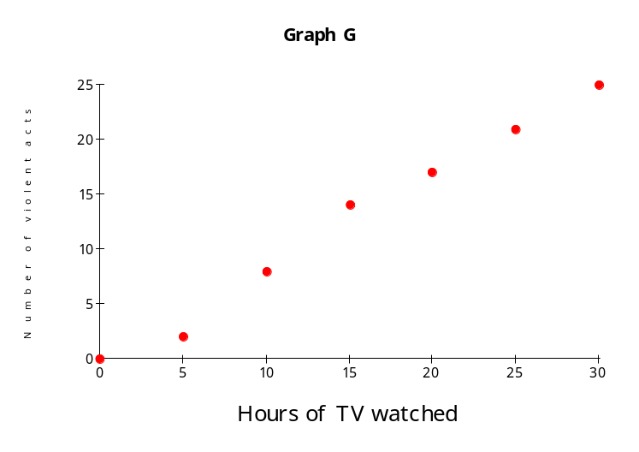

What type of correlation does graph G show?

It is also worth being careful about the use of inappropriate scales and omitting parts of axes – this may make patterns look more dramatic.

To do:
Now circle your answers to these questions to generate data to plot suitable graphs.

- What is your favourite takeaway food?
Chinese / Indian / Pizza / Fish & Chips / KFC / McDonalds

- What time do you get up in a morning?
6-31 to 6-45 / 6-46 to 7-00 / 7-01 to 7-15 / 7-16 to 7-30 /
7-31 to 7-45 / 7-46 to 8-00 / 8-01 to 8-15

- How many hours do you spend doing exercise each week?
0 / 1 / 2 / 3 / 4 / 5 / 6 / 7 / 8 / 9 / 10
How fit do you think you are?
1 / 2 / 3 / 5 / 5 / 6 (where 1 is unfit and 6 is really fit)

Collate the class data on the board.
Decide what graph you will draw for each set of data and then draw them using graph paper.

